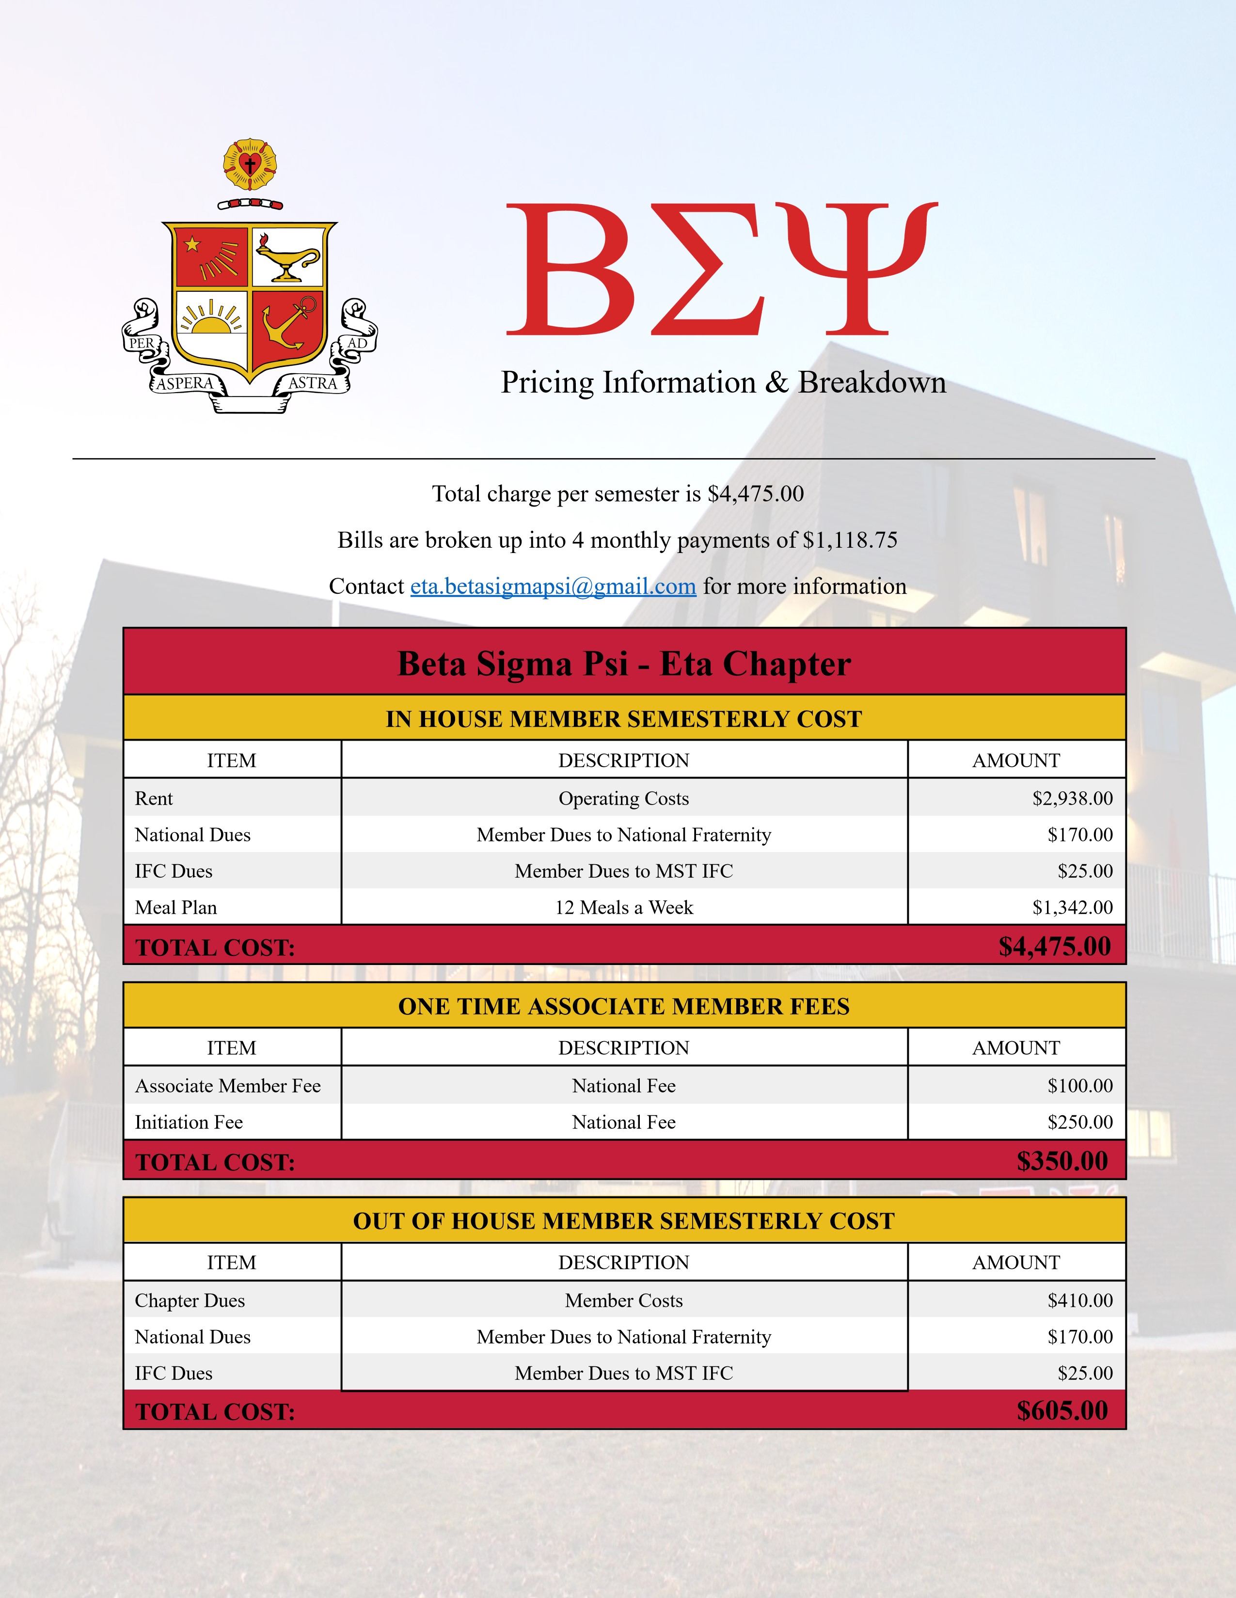
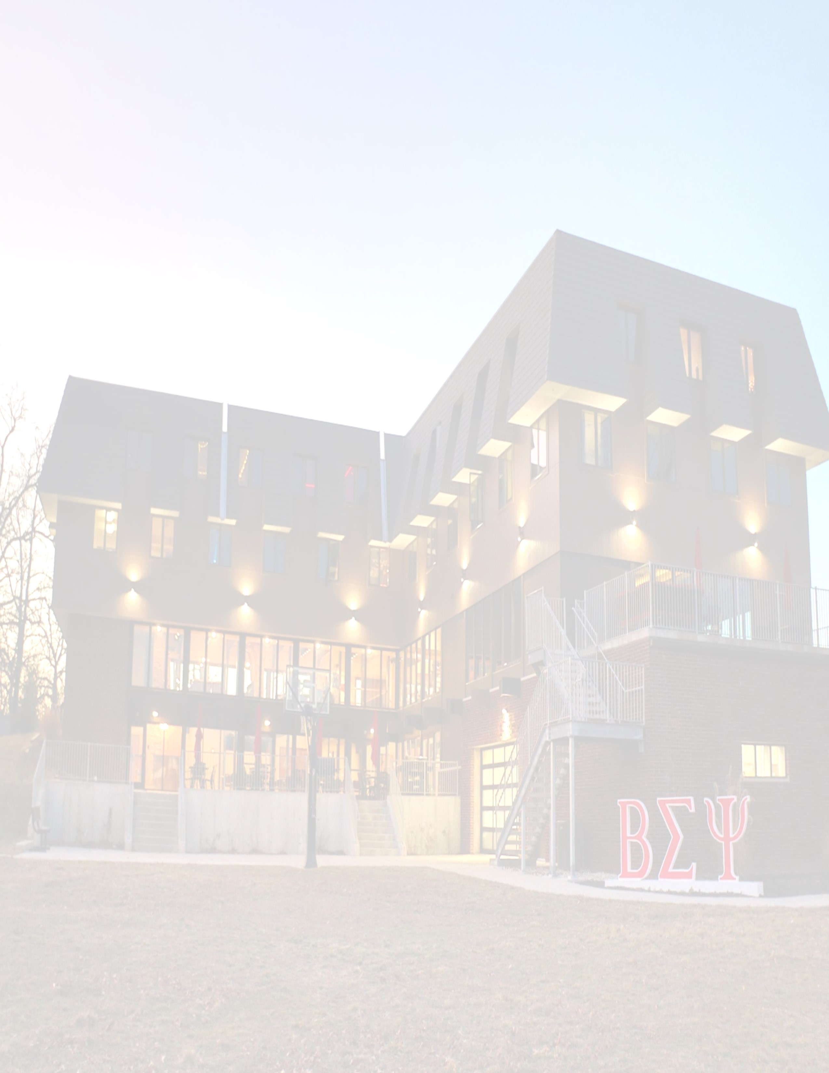

All Amenities Include:

●

Newly renovated House with completely new addition

●

Newly renovated rooms and brand new rooms for all in-house members

●

Free designated parking for all members

●

Stocked kitchen with professional appliances

●

12
meals per week prepared by professional Chef as well as continental breakfast

●

4
study rooms with whiteboards and TVs for group study sessions or for quiet interviews

●

Alumni networking and professional development for S&T career fairs

●

Free-to-use printers for all members

●

Study/Quiet hours promote active learning environments throughout the school week

●

Free access to largest garage/shop throughout Greek Life for individual and academic projects

●

Access to comprehensive online file system to promote member study habits

●

Home theatre in Great Room with seating for all members for large sports events or movie nights

●

Multiple game rooms with billiards, table tennis, poker, a piano, and air hockey

●

Large patio area for house BBQs, outdoor seating, and outside room for socials

●

Free WiFi and ethernet services in every room of the house for lightning-fast internet access

●

Desk, bed, and mattress provided in each room

●

Members may fully customize each room with whatever furnishings or decorations they bring

●

Lounge areas on 2nd and 3rd floors with TVs, comfy couches, and water fountains

●

Scholarships available for all members. Visit mstbetasig.org/scholarships for more info

●

Mail services & stocked library with textbooks

●

Large chapter room for house meetings as well as for guest speakers and professional development

●

New industrial grade washers and dryers

